MGMS – Sub project allocation

Functional Specification Document

Ver. 1.4

Version History
Date | Description

Table of Contents

Version History 2
1 Introduction 4
1.1 Purpose 4
1.2 Scope 4
1.3 Assumptions 5
1.4 Constraints 5
2 Sub allocate projects 5
2.1 Create sub project 5
2.2 Attachments 7
2.3 Withdrawal/Closure 8
2.4 Fund transfer 10
3 Business Rules 11
4 Status Messages 12

Introduction

Purpose

This document provides the requirements and functional specifications for the sub project allocation section in the Multisite Grant Management System project.
This is not a project plan or a design document. It is a guide for system architecture and development, not for phasing, timelines or deliverables.
Finally, this is a ‘living document’ and the specification will change, continuously, as the project proceeds. More details will be added and the existing information edited as the requirements, scenarios and use cases evolve in the course of the project.

Scope

In this section, the grantee institution can divide the main project to sub projects to be further assigned to other institutions.
- The details saved of a sub project are: name, start & end dates, receiving institution, amount of allocation, sanction order number (Letter no :), date of allocation and any remarks by the user.
- Now the user’s institution has become the “Grantor” who has assigned a (sub) project and allocated an associated grant amount to the receiving institution, the Grantee.
- What is categorized as “sub project” by the grantor is categorized as “project” by the grantee and it appears as a line item in the Project List of the sub grantee.

Grant withdrawal/closure - Using this functionality the institution can record the status of the grants allocated for its sub project (assigned to a grantee institution), at various points of project duration.
For e.g., “Withdrawal” status indicates that the particular grant allocation was withdrawn from the subproject prematurely for some reason. A status “closed” may indicate that the subproject has ended and therefore the grant for that subproject is closed.
The details saved are: Grant allocation status, date of this particular entry and user’s remarks, if any.

Assumptions

The top level grantor, his immediate grantee and the sub grantees further down in the chain, are all users of the MGMS application.

Constraints

-

Sub allocate projects

Create sub project
The institution can divide the main project to sub projects to be further assigned to other institutions.
- The details saved of a sub project are: name, start & end dates, receiving institution, amount of allocation, sanction order number (Letter no :), date of allocation and any remarks by the user.
- Now the user’s institution has become the “Grantor” who has assigned a (sub) project and allocated an associated grant amount to the receiving institution, the Grantee.
- What is categorized as “sub project” by the grantor is categorized as “project” by the grantee
- Grant allocations may be made any number of times to a grantee, for a project.
- The same project cannot be assigned to two/more different institutions.
- (The system validates that sub-project start and end date falls within the start and end date of the main project).
- After creating a subproject, any number of associated documents may be uploaded into the GMS, for future reference.
Screen & Control Description

Figure 1: Sub project Allotment
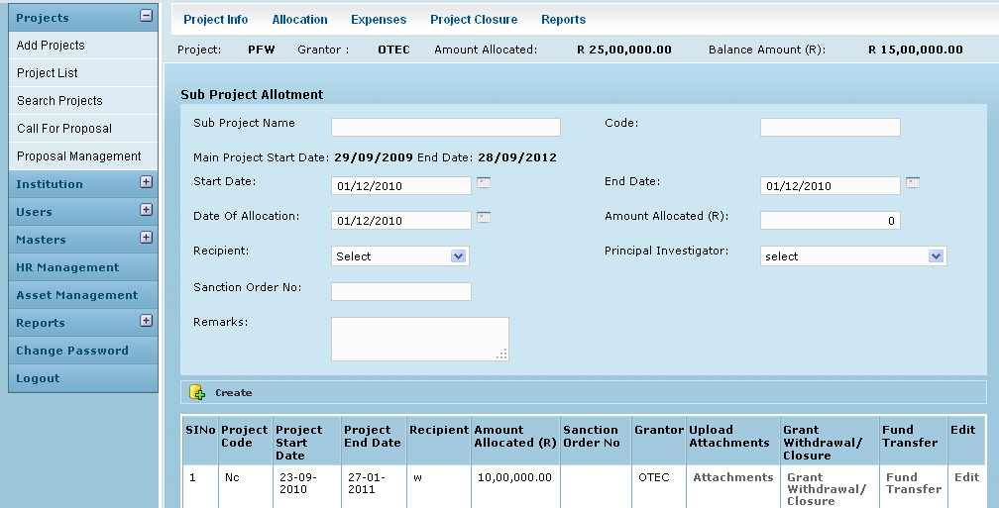

Field /Label | Input-Control | Data Type | Details
Project: | Auto-populated | String | Display Project Code
Grantor: | Auto-populated | String
Amount Allocated: | Auto-populated | Number
Balance Amount | Auto-populated | Number
Sub Project Allotment
Sub Project Name: | Textbox | String
Code: | Textbox | String
Main Project Start Date: | Auto-populated | Date
End Date | Auto-populated | Date | (Main Project)
Start Date | textbox-calendar | Date | (of the sub allocated project ) Validation check required to ensure that Sub project Date period is within the Main project period.
End Date | textbox-calendar | Date | (of the sub allocated project) Validation check required to prevent user from entering Sub project End Date that is earlier to sub project Start Date
Recipient: | Listbox | String
Date of Allocation: | Calendar | Date
Amounted Allocated (Rs): | Textbox | Number
Principal Investigator | Listbox
Sanction Order No: | Textbox
Remarks: | Textarea | String
Create | Button
SlNo | Auto increment-populated
Project Code: | Auto-populated | String
Project Start Date: | Auto-populated | Date
Project End Date: | Auto-populated | Date
Recipient: | Auto-populated | String
Amount Allocated: | Auto-populated | Number
Sanction Order No: | Auto-populated | String
Grantor | Auto-populated | String
Upload Attachments | Button |  | Opens up page for browsing-uploading attachments
Grant/Withdrawal//Closure | Button |  | Opens up page where user can record the particular grant’s status
Fund Transfer | Button |  | Opens up Fund Transfer page where user can record associated fund transfers made to grantee.
Edit | Button |  | Can edit the fields above

Attachments

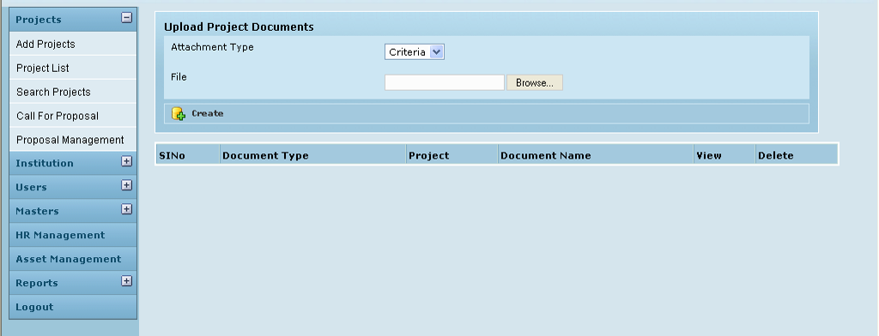

Field /Label | Input-Control | Data Type | Details
Upload Project Documents
Attachment Type | Listbox | String
File | textbox, “Browse” button | String
Create | button
Sl No | Auto increment/ populated
Attachment Type | Auto populated | String
Project | Auto populated | String
Document Name | Auto populated
View | Button |  | Opens the file for viewing, in a different window.
Delete | Button |  | Removes the attachment

Withdrawal/Closure

Figure 2: Grant allocation status
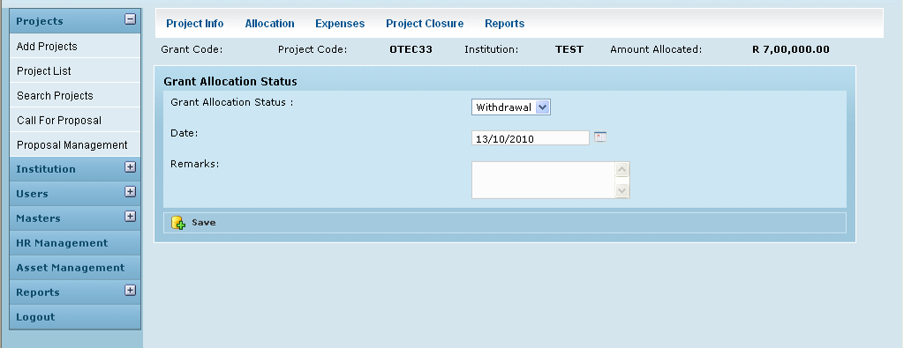

Field /Label | Input-Control | Data Type | Details
Grant Code: | Auto populated | String
Project Code: | Auto populated | String
Institution: | Auto populated | String
Amount Allocated: | Auto populated | Number
Grant Allocation Status | Listbox | String
Date: | textbox-calendar | Date
Remarks: | Textarea | String
Save | Button

Fund transfer

Figure 3: Fund Transfer
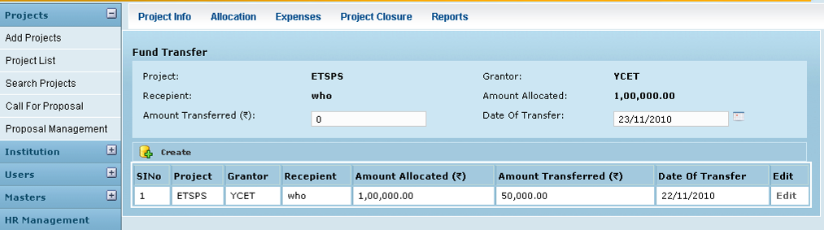

Field /Label | Input-Control | Data Type | Details
Fund Transfer
Project: | Auto-populated | String
Grantor: | Auto-populated | String
Recipient: | Auto-populated | String
Amount Allocated: | Auto-populated | Number
Amount Transferred: | Textbox | Number
Date of Transfer: | Textbox-calendar | Date
Create | Button

Edit

Figure 4: Edit Sub project Allocation
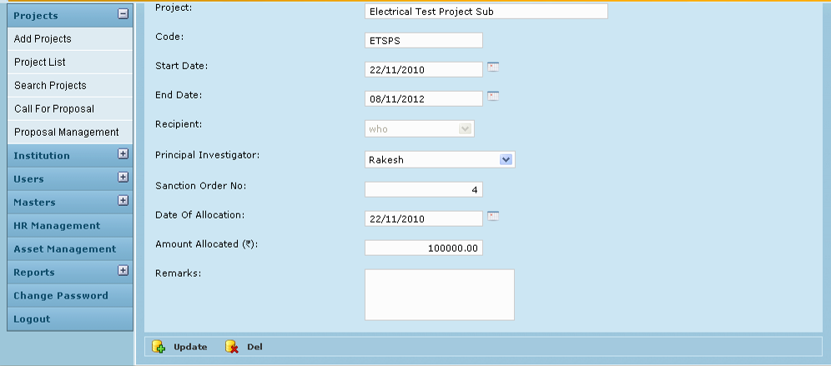

Field /Label | Input-Control | Data Type | Remarks / Edit Check
Project | Auto-populated | String
Code: | Auto-populated | String
Start Date: | Listbox | String
End date | Listbox | Number
Recipient
Principal Investigator | Listbox | String
Saction Order No:
Date Of Allocation | Textbox | Date
Amount Allocated: | Auto-populated | Number
Remarks: | Textarea | String
Update | Button |  | Sub Project Allotment changes saved
Del | Button |  | Removes the entry

Business Rules

- Grant allocations may be made any number of times to a grantee, for a project.
- The same project cannot be assigned to two/more different institutions.
- The system validates that sub-project start and end date falls within the start and end date of the main project
- After creating a subproject, any number of associated documents may be uploaded into the GMS, for future reference.

Status Messages

Sl No | Status Message
 | Created Successfully
 | Updated Successfully
1 | Deleted Successfully
2 | The Requested Record Not Found
3 | The Record can't be deleted, Already in use
4 | The Record Already Exists
5 | Please Enter a valid email address
6 | You can not delete yourself, please login as another admin and try again
7 | The Amount should not exceed the Allocated Amount for the Project
8 | Project End Date should be greater than Start Date
9 | Please enter the Amount Allocated
10 | Please enter Proper Amount
11 | Please enter a valid Amount
12 | Please enter the Recipient
13 | Please enter granter
14 | Sub project End Date should be greater or equal to sub project Start Date
15 | Sub project Date period should be between the Main project date
16 | Amount Exceeded ,fund Allocation not possible
17 | Allocation Date should be greater than Project Start Date
18 | Invalid Amount
19 | Please enter the Investigator
20 | Please Enter Amount Less Than Or Equal To Balance Amount
21 | Please Enter Percentage Of Completion
22 | Please Enter Numeric Value For Percentage Of Completion
23 | Please Select a Fund Transfer
24 | Please wait
25 | Date of Transfer should be less than current date
26 | Date of Transfer should be greater than or equal to Project Start Date
27 | Amount Exceeded ,fund Allocation not possible
28 | Please Enter Amount Less Than Or Equal To Balance Amount

